**DAILY ONLINE ACTIVITIES SUMMARY**

|  |  |  |  |  |  |  |  |  |
| --- | --- | --- | --- | --- | --- | --- | --- | --- |
| **Date:** | **08-06-2020** | | | | | **Name:** | **Nihal Rafiq** | |
| **Sem & Sec** | **4th A** | | | | | **USN:** | **4AL18CS052** | |
| **Online Test Summary** | | | | | | | | |
| **Subject** | | **Complex Analysis, Probability and Statistical Method** | | | | | | |
| **Max. Marks** | | **30** | | **Score** | | | **22** | |
| **Certification Course Summary** | | | | | | | | |
| **Course** | **Data Visualization using Python** | | | | | | | |
| **Certificate Provider** | | | **Great Learning Academy** | | **Duration** | | | **2 hours** |
| **Coding Challenges** | | | | | | | | |
| **Problem Statement:**  **1. Write a C++ program to swap a two numbers using the bridge concept**  **2. Write a java program to check whether the given matrix is a magic square or not**  **3. C program to generate all the set partitions of the n numbers beginning from 1 to so on** | | | | | | | | |
| **Status: Executed** | | | | | | | | |
| **Uploaded the report in Github** | | | | | **Yes** | | | |
| **If yes Repository name** | | | | | **https://github.com/nihal-art/lockdown-coding** | | | |
| **Uploaded the report in slack** | | | | | **Yes** | | | |

Online Test Details:

Today’s online test was on 2nd module of 18MAT41. The duration of the test is 40 minutes from 09:30am to 10:00am. Questions were of multiple choice. Score I received is 22/30

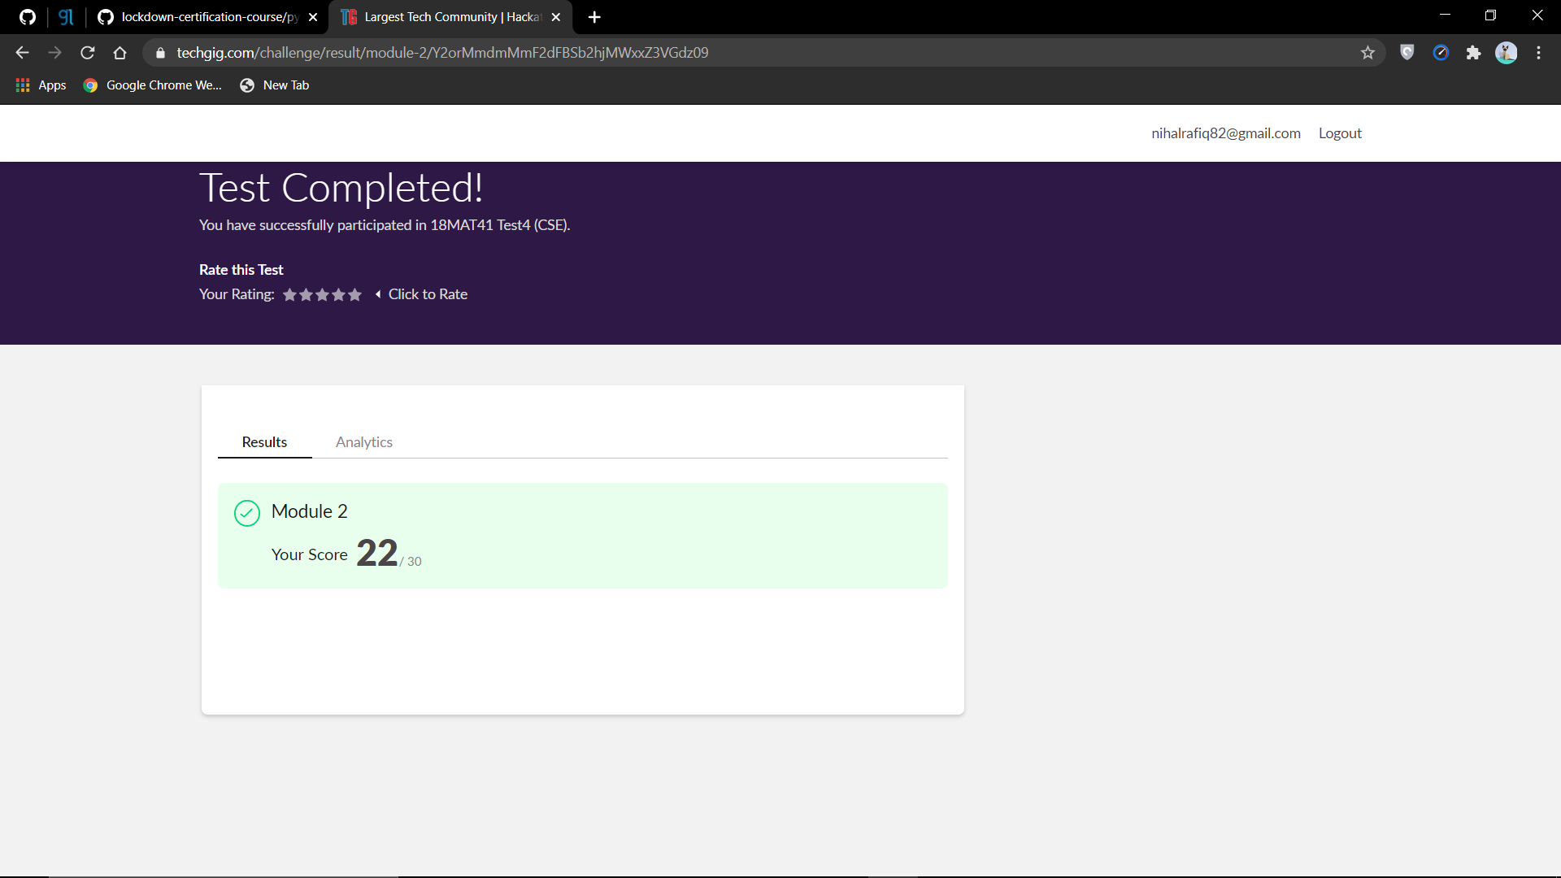

Certification Course Details:

I have opted for Data Visualization using Python.

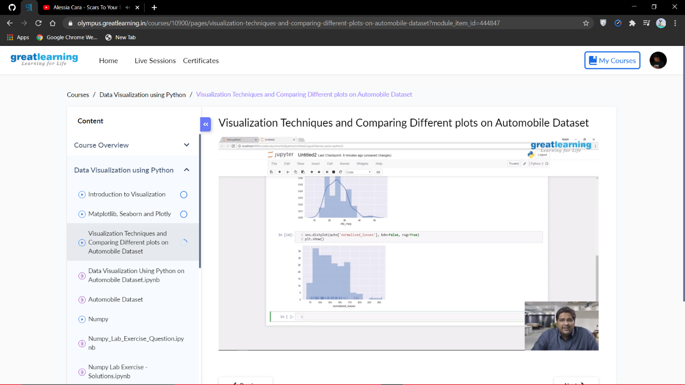

Coding Challenges Details:

1. Write a C++ program to swap a two numbers using friend as a bridge concept

Example: Input a=10 b=20

Output a=20 b=10

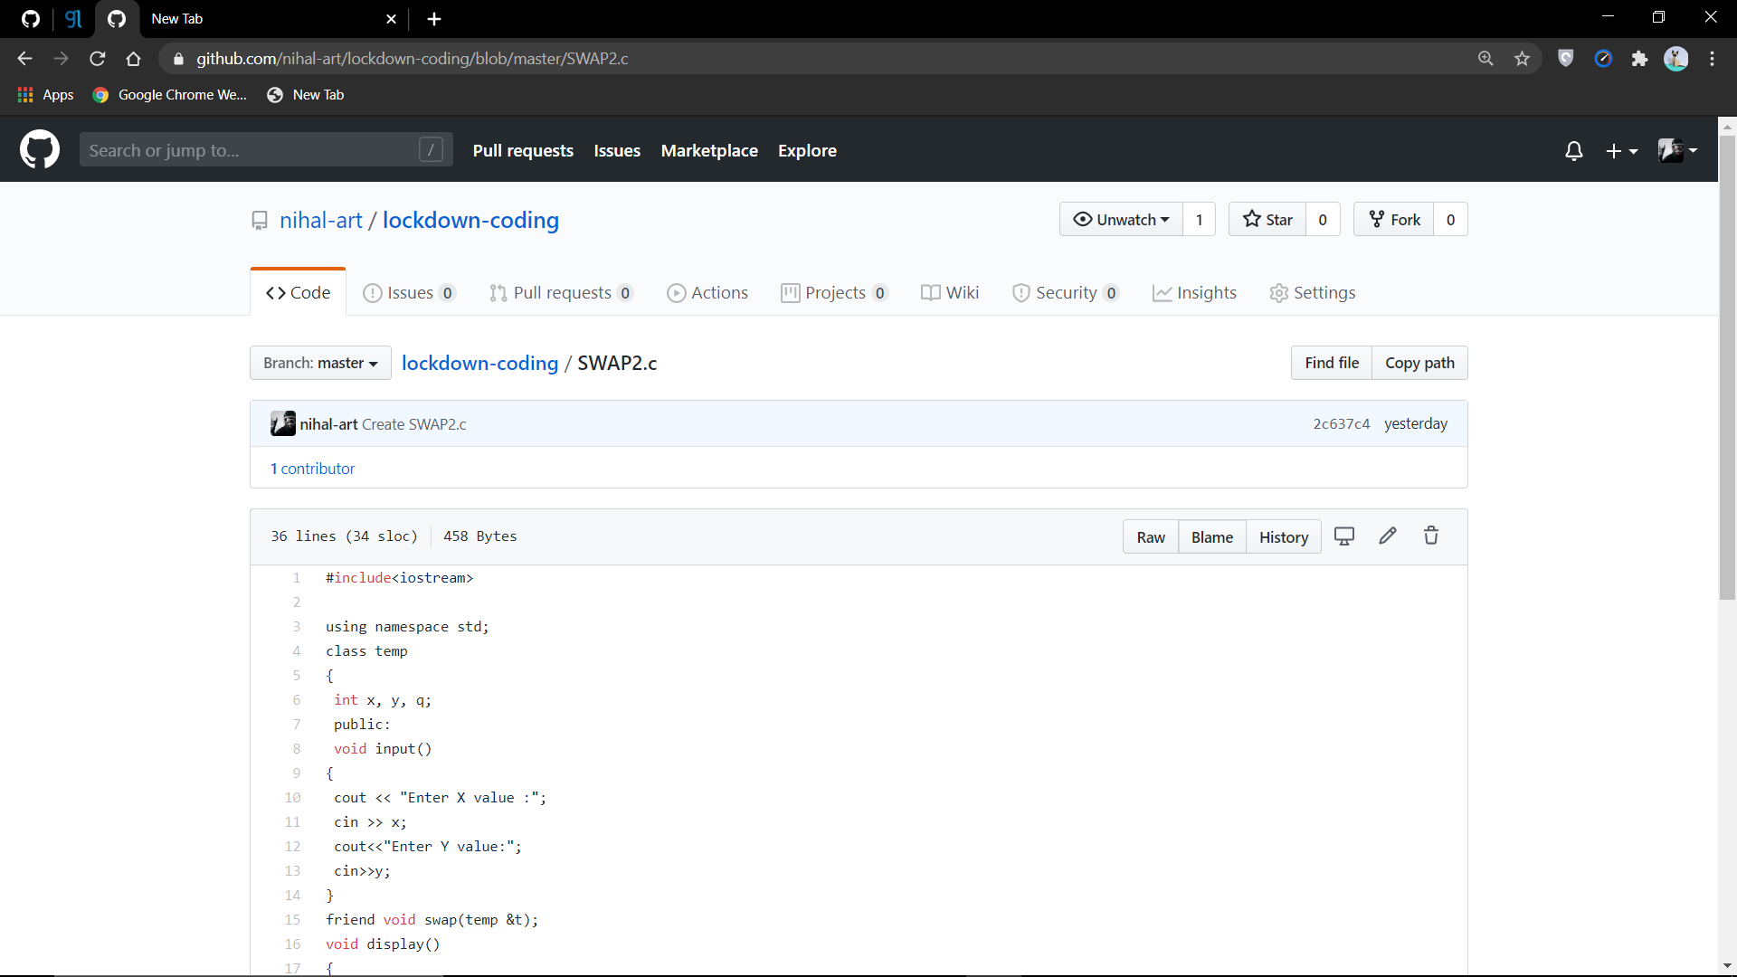

2. Write a java program to check whether the given matrix is magic square or not. Given a matrix, check whether it’s Magic square or not. A Magic square is n x n matrix of distinct element from 1 to n2 where sum of array row, column or diagonal is always equal to same number

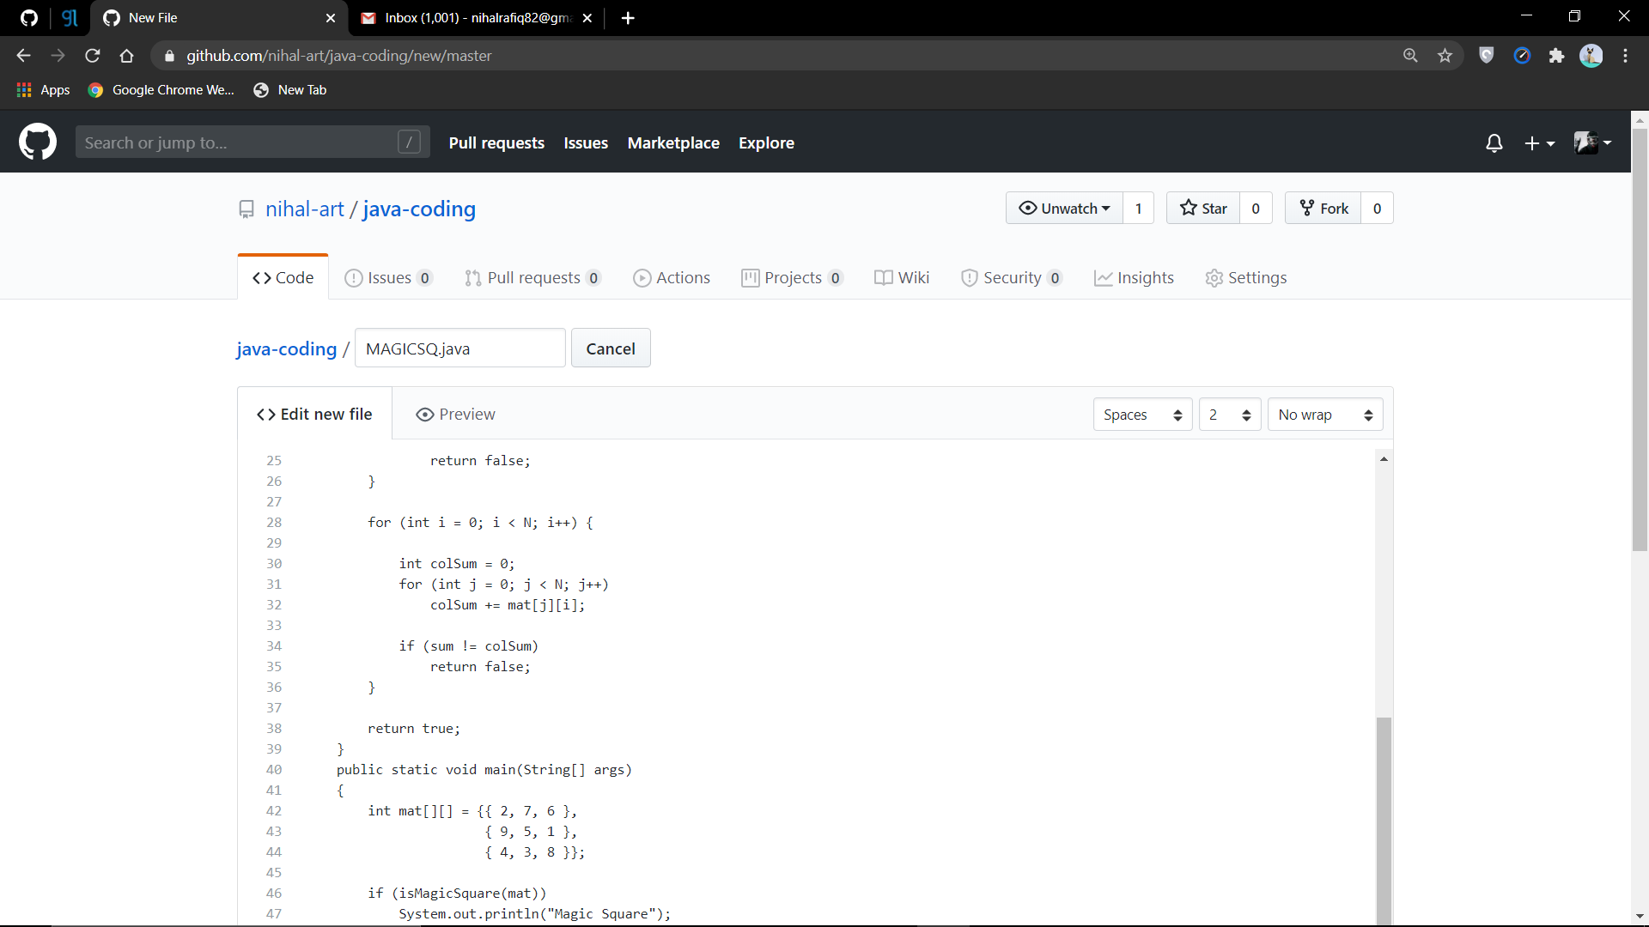

3. C program to generate all the set partitions of n numbers beginning from 1 and so on. This algorithm partitions an integer into numbers which sum up to form the original number. It generates partitions of a set of numbers for a given range

